A
Real-Time Research Project
On
AI-DRIVEN DDOS PROTECTION ARCHITECTURE AND TOOLS
(Submitted in partial fulfillment of the requirements for the award of Degree)

BACHELOR OF TECHNOLOGY
In

COMPUTER SCIENCE AND ENGINEERING
By

PATNALA HARIKA (247R1A05X7)
DONTHULA VISHWAK (247R1A05U3)
MUDUSU ARAVIND (247R1A05W8)

Under the Guidance of

K.PRAVEEN KUMAR
(Assistant Professor)



DEPARTMENT OF COMPUTER SCIENCE AND ENGINEERING
CMR TECHNICAL CAMPUS

UGC AUTONOMOUS
(Accredited by NAAC, NBA, Permanently Affiliated to JNTUH, Approved by AICTE, New Delhi) Recognized Under Section 2(f) & 12(B) of the UGCAct.1956, Kandlakoya (V), Medchal Road, Hyderabad-501401.
April, 2026

DEPARTMENT OF COMPUTER SCIENCE AND ENGINEERING


CERTIFICATE
This is to certify that the project entitled “AI DRIVEN DDOS PROTECTION ARCHITECTURE AND TOOLS” being submitted by P.Harika (247R1A05X7), D.Vishwak (247R1A05U3) & M.Aravind (247R1A05W8) in partial fulfillment of the requirements for the award of the degree of B.Tech in Computer Science and Engineering to the CMR Technical Campus ,Hyderabad, during the year 2025-26.

The results embodied in this thesis have not been submitted to any other University or Institute for the award of any degree or diploma.

K.Praveen Kumar | Dr. Nuthanakanti Bhaskar
Assistant Professor  INTERNAL GUIDE | HoD

ACKNOWLEDGEMENT

We take this opportunity to express our gratitude to the people who have been instrumental in the successful completion of this project, we take this opportunity to express our profound gratitude and deep regard to our guide k.Praveen Kumar , Associate Professor for his exemplary guidance, monitoring and constant encouragement throughout the project work. The blessing, help and guidance given by him shall carry us a long way in the journey of life on which we are about to embark.
We take this opportunity to extend our heartfelt appreciation to the Project Review Committee (PRC) Coordinators—Dr. J. Narasimharao, Mrs. V. Neeraja, Mrs. G. Swarnalatha and Mrs. L. Swathi —for their unwavering support, insightful guidance, and valuable inputs, which played a crucial role in steering this project through its various stages.

Our sincere appreciation also goes to Dr. Nuthanakanti Bhaskar, Head, for his encouragement and continuous support in ensuring the successful completion of our project.
We are deeply grateful to Dr. A. Raji Reddy, Director, for his cooperation throughout the course of this project. Additionally, we extend our profound gratitude to Sri. Ch. Gopal Reddy, Chairman, Smt. C. Vasantha Latha, Secretary and Sri. C. Abhinav Reddy, Vice-Chairman, for fostering an excellent infrastructure and a conducive learning environment that greatly contributed to our progress.

We also acknowledge and appreciate the guidance and assistance provided by the faculty and staff of CMR Technical Campus, whose contributions have been invaluable in bringing this project to fruition.
Lastly, we sincerely thank our families for their unwavering support and encouragement. We also extend our gratitude to the teaching and non-teaching staff of CMR Technical Campus for their guidance and assistance. Their contributions, along with the support of everyone who helped directly or indirectly, have been invaluable in the successful completion of this project.

Patnala Harika(247R1A05X7)
Donthula Vishwak(247R1A05U3)
Mudusu Aravind(247R1A05W8)

VISION AND MISSION

INSTITUTE VISION:
To Impart quality education in serene atmosphere thus strive for excellence in Technology and Research.

INSTITUTE MISSION:
- To create state of art facilities for effective Teaching- Learning Process.

- Pursue and Disseminate Knowledge based research to meet the needs of Industry & Society.

- Infuse Professional, Ethical and Societal values among Learning Community.

DEPARTMENT VISION:
To provide quality education and a conducive learning environment in computer engineering that foster critical thinking, creativity, and practical problem-solving skills.

DEPARTMENT MISSION:
- To educate the students in fundamental principles of computing and induce the skills needed to solve practical problems.

- To provide State-of-the-art computing laboratory facilities to promote industry institute interaction to enhance student’s practical knowledge.

- To inculcate self-learning abilities, team spirit, and professional ethics among the students to serve society.

ABSTRACT

With the increasing reliance on networked systems for critical infrastructure, the threat of Distributed Denial of Service (DDoS) attacks has become a significant concern for network administrators and security professionals. DDoS attacks aim to disrupt the availability of services by overwhelming a target system with an excessive amount of traffic, rendering it inaccessible to legitimate users. Traditional detection methods often struggle to accurately identify DDoS attacks amidst the vast volume of network traffic.
This paper proposes a novel approach for the detection of DDoS attacks based on entropy analysis. Entropy, a measure of randomness or disorder, is applied to network traffic patterns to discern anomalous behavior indicative of a DDoS attack. By analyzing the entropy of various network attributes such as packet size, source IP addresses, destination ports, and protocol types, this approach seeks to differentiate between normal and malicious traffic.
The proposed methodology employs the CUSUM (Cumulative Sum) entropy technique to detect abnormal changes in network traffic patterns. The system captures and preprocesses network traffic data, computes entropy measures, establishes baseline entropy profiles for normal operation, and then continuously monitors live traffic for deviations from those baselines.
The methodology involves the following key steps: collection and preprocessing of network traffic data, calculation of entropy for selected network attributes, establishment of baseline entropy values for normal network behavior, monitoring real-time traffic and comparing entropy values against the baseline, identification of deviations from normal entropy patterns, and implementation of appropriate response mechanisms such as traffic filtering or rate limiting to mitigate the impact of detected attacks.
The effectiveness of the proposed entropy-based approach is evaluated through experimentation using real-world network traffic datasets and simulated DDoS attack scenarios. Results demonstrate the capability of entropy analysis to accurately detect DDoS attacks with an accuracy of 92%, while minimizing false positives. Furthermore, the approach exhibits robustness against various types of DDoS attacks, including volumetric, protocol-based, and application-layer attacks.
In conclusion, the utilization of entropy-based analysis presents a promising avenue for enhancing DDoS detection capabilities in network security. By leveraging the inherent properties of entropy to discern patterns in network traffic, this approach offers a proactive and efficient means of safeguarding against the disruptive effects of DDoS attacks on critical infrastructure and online services.

LIST OF FIGURES
FIGURE NO |  | FIGURE NAME |  | PAGE NO
Figure 3.1 |  | Architecture of the DDoS Attack Detection Scheme |  | 14
Figure 3.2 |  | Dataflow Diagram of “DETECTION OF DDOS ATTACK USING ENTROPY APPROACH” |  | 17
Figure 8.1 |  | DDoS Dataset with network traffic records and class labels |  | 37
Figure 8.2 |  | CUSUM Entropy Computation Code |  | 38
Figure 8.3 |  | Main Application Interface |  | 39
Figure 5.4 |  | Dataset Upload Screen |  | 40
Figure 5.5 |  | Dataset loaded with record details and class distribution graph |  | 41
Figure 5.6 |  | Pre-processed Dataset with all numeric values |  | 42
Figure 5.7 |  | Normalized Training Features |  | 43
Figure 5.8 |  | CUSUM Model Training Results with Confusion Matrix (92% Accuracy) |  | 44
Figure 5.9 |  | Test Data Upload Screen |  | 45
Figure 5.10 |  | Prediction Results — Normal or Attack classification |  | 46

LIST OF TABLES

TABLE NO |  | TABLE NAME |  | PAGE NO
Table 6.2.1 |  | Uploading Dataset |  | 44
Table 6.2.2 |  | Dataset preprocessing |  | 44
Table 6.2.3 |  | Normalize training features |  | 45
Table 6.2.4 |  | Train cusum entropy model |  | 45

Table 6.2.5 |  | Normal traffic prediction |  | 45
Table 6.2.6 |  | Attack traffic prediction |  | 46

Table 6.2.7 |  | Comparsion graph generation |  | 46

TABLE OF CONTENTS

ABSTRACT i
LIST OF FIGURES ii
LIST OF TABLES iii
- INTRODUCTION 1
  - PROJECT PURPOSE 3
  - PROJECT FEATURES 4
- LITERATURE SURVEY 6
  - REVIEW OF RELATED WORK 8
  - DEFINITION OF PROBLEM STATEMENT 10
  - EXISTING SYSTEM 10
  - PROPOSED SYSTEM 12
  - OBJECTIVES 14
  - HARDWARE & SOFTWARE REQUIREMENTS 14
    - HARDWARE REQUIREMENTS 15
    - SOFTWARE REQUIREMENTS 15
- SYSTEM ARCHITECTURE & DESIGN 16
  - PROJECT ARCHITECTURE 17
  - DESCRIPTION 19
  - DATA FLOW DIAGRAM 20
- IMPLEMENTATION 23
  - ALGORITHMS USED 24
  - SAMPLE CODE 27
- RESULTS & DISCUSSION 34
- VALIDATION 42
  - INTRODUCTION 43
  - TEST CASES 44
- CONCLUSION & FUTURE ASPECTS 48
  - PROJECT CONCLUSION 49
  - FUTURE ASPECTS 50
- BIBLIOGRAPHY 52
  - REFERENCES 53
  - GITHUB LINK 54

1.INTRODUCTION

1. INTRODUCTION

The digital landscape of the 21st century is characterised by an ever-increasing dependency on networked infrastructure. From banking systems and e-commerce platforms to government portals and healthcare services, practically every critical function of modern society depends on uninterrupted internet connectivity. This dependency has made network availability a primary concern for security engineers worldwide. Among the many threats targeting network availability, Distributed Denial of Service (DDoS) attacks remain among the most destructive, sophisticated, and difficult to mitigate.

A DDoS attack is a coordinated attempt by a large number of compromised machines, collectively called a botnet, to overwhelm a target server or network with a massive volume of requests or malformed packets. The sheer volume of this traffic exhausts the computational resources, bandwidth, or connection tables of the target system, rendering it unable to service legitimate users. Unlike simple Denial of Service (DoS) attacks originating from a single machine, the distributed nature of DDoS attacks makes source-based blocking extremely difficult, as traffic arrives from thousands of different IP addresses simultaneously.

The global cost of DDoS attacks has been escalating year over year. According to industry reports, large-scale DDoS incidents can cost organisations upwards of hundreds of thousands of dollars per hour in downtime, incident response, and reputational damage. High-profile attacks have targeted major financial institutions, DNS infrastructure providers, gaming networks, and even national government websites, demonstrating that no sector is immune. The increasing availability of DDoS-for-hire services on the dark web has further democratised the ability to launch attacks, meaning even unskilled adversaries can now rent a botnet and direct a devastating assault against any target.

Traditional countermeasures such as rate limiting, IP blacklisting, and signature-based intrusion detection systems (IDS) have proven inadequate against the dynamic and evolving nature of modern DDoS attacks. Signature-based systems can only detect previously known attack patterns and fail against novel attack vectors. Rate limiting introduces excessive latency for legitimate users and is easily bypassed by distributing the attack load. There is therefore a strong and growing demand for intelligent, adaptive, and real-time detection mechanisms that do not rely on prior knowledge of attack signatures.

Entropy-based detection represents a fundamentally different approach. Entropy, borrowed from information theory, quantifies the unpredictability or disorder within a data distribution. Under normal operating conditions, network traffic exhibits a characteristic entropy profile: source IP addresses are diverse but follow recurring patterns, packet sizes cluster around predictable values, and port distributions reflect the services being accessed. During a DDoS attack, these distributions change dramatically. A flood of packets from many spoofed IPs will cause unusually high source IP entropy, while a volumetric attack concentrated on a single destination port will cause abnormally low destination port entropy. These statistical anomalies can be detected rapidly and with high accuracy using entropy analysis.

The CUSUM (Cumulative Sum) algorithm, originally developed for statistical process control in manufacturing, is particularly well-suited to detecting these sudden changes. By tracking the cumulative deviation of an entropy measure from its established baseline, CUSUM can raise an alarm the moment the deviation exceeds a threshold, providing early detection with minimal lag.

This project implements such a system. Using a labelled DDoS network traffic dataset, the system trains a CUSUM entropy model and demonstrates its ability to classify test records as either normal traffic or DDoS attacks. The system further compares its performance against conventional classifiers, validates its test cases, and provides a clear GUI for operation and visualisation.

1.1 PROJECT PURPOSE
The primary purpose of this project is to develop a robust, accurate, and computationally efficient system for the real-time detection of DDoS attacks in network traffic using entropy-based statistical analysis. Existing commercial solutions are expensive, often proprietary, and frequently lag in adapting to new attack variants. Academic literature has demonstrated the theoretical promise of entropy analysis, but accessible, end-to-end implementations with GUI-based interfaces and comprehensive evaluation remain scarce.

This project addresses that gap by providing a complete software pipeline: from data ingestion and preprocessing through entropy computation and anomaly scoring to final classification and reporting. The system is designed to be transparent, interpretable, and extensible, making it suitable both as a research prototype and as a foundation for a production-grade security tool.

From a societal perspective, the purpose extends beyond technical achievement. Critical national infrastructure, including power grids, water management systems, financial networks, and emergency response platforms, increasingly relies on internet connectivity. Protecting these systems from availability attacks is a matter of public safety. This project contributes to that broader goal by advancing the state of accessible, open-source DDoS detection technology.

1.2 PROJECT FEATURES
The following key features distinguish this project from simpler DDoS detection approaches:

Entropy-Based Statistical Detection:
Rather than relying on handcrafted rules or static signatures, the system uses information-theoretic measures to characterise network traffic. Packet-level, flow-level, and aggregate entropy values are computed across multiple network attributes simultaneously, providing a rich multi-dimensional view of traffic behaviour that is sensitive to a wide range of attack types.
CUSUM Change Detection:
The Cumulative Sum algorithm provides rapid, statistically principled detection of change points in entropy time series. Unlike simple threshold comparisons, CUSUM accumulates evidence over time, making it resistant to transient fluctuations while remaining sensitive to genuine sustained changes caused by attacks. This results in a low false positive rate alongside a low false negative rate.
Comprehensive Data Pipeline:
The system implements a complete data processing pipeline including dataset loading, feature extraction, normalisation, entropy computation, model training, and real-time inference. Each stage is modular and can be independently updated or replaced.
Performance Evaluation Framework:
The system includes a built-in evaluation framework that computes accuracy, precision, recall, and F1-score against labelled test data and presents confusion matrix visualisations. This allows rigorous benchmarking and comparison against alternative classifiers.
Interactive GUI:
A Tkinter-based graphical user interface allows non-technical users to interact with the system, upload datasets, trigger training and evaluation, visualise statistical distributions, and test individual samples. This significantly lowers the barrier to adoption.
Scalability and Adaptability:
The system is designed to be extended to accommodate new feature sets, larger datasets, cloud deployment, and integration with live network monitoring tools such as Wireshark, Zeek, or NetFlow collectors.

2.LITERATURE SURVEY

2. LITERATURE SURVEY

With the rapid growth of internet-based services and cloud computing, network security has become a critical concern for organizations and individuals. Among various cyber threats, Distributed Denial of Service (DDoS) attacks are one of the most severe, as they aim to disrupt services by overwhelming systems with massive traffic. Traditional security mechanisms often fail to detect these attacks effectively due to their dynamic and distributed nature. This necessitates the use of advanced techniques such as entropy-based analysis and machine learning methods to improve detection accuracy and response time.

This literature survey reviews existing research on DDoS attack detection, focusing on entropy-based techniques, statistical models, and machine learning approaches. It highlights their strengths, limitations, and areas requiring improvement. The survey emphasizes entropy analysis, hybrid detection models, real-time monitoring, and adaptive threshold mechanisms to enhance detection performance.

Early approaches to DDoS detection relied on signature-based and rule-based techniques. These methods used predefined attack patterns to identify malicious traffic. While effective for known attacks, they failed to detect new or unknown attack patterns. Researchers such as Douligeris and Mitrokotsa (2004) proposed classification-based approaches to identify DDoS attacks, but these methods lacked adaptability in dynamic environments.

Later, anomaly-based detection methods were introduced, which analyze deviations from normal network behavior. Entropy-based approaches became popular as they measure randomness in network traffic. Johnson et al. (2018) proposed an entropy-based model that analyzes packet header fields to detect abnormal traffic patterns. Their approach showed improved detection accuracy but required careful threshold selection.

Wang and Chen (2020) introduced flow entropy techniques in Software-Defined Networks (SDN), enabling dynamic monitoring of traffic flows. Their approach effectively distinguished between normal and attack traffic, but computational overhead remained a challenge in large-scale networks.
Machine learning techniques further enhanced DDoS detection capabilities. Brown et al. (2021) proposed a classification model using entropy features combined with supervised learning algorithms. Their approach improved detection accuracy and reduced false positives. However, it required large labeled datasets for training.

Hybrid approaches combining entropy with statistical and machine learning techniques have also been explored. Smith and White (2022) introduced a hybrid entropy-statistical model for IoT networks, improving detection in resource-constrained environments. Their method demonstrated better adaptability but increased system complexity.

Recent research focuses on real-time detection using dynamic entropy thresholds. Garcia et al. (2023) proposed a model that adjusts entropy thresholds based on current network conditions, improving responsiveness and reducing false alarms. However, the model requires continuous monitoring and tuning.

Additionally, deep learning approaches are being explored for DDoS detection. Neural networks and recurrent models can capture complex traffic patterns and temporal dependencies. However, these models are computationally expensive and require high-performance hardware.
Despite these advancements, several challenges remain. Entropy-based methods require proper threshold selection, machine learning models depend on high-quality datasets, and real-time detection demands efficient processing. The proposed system aims to overcome these limitations by integrating entropy-based analysis with machine learning techniques for accurate and scalable DDoS detection.

2.1 REVIEW OF RELATED WORK

The detection of DDoS attacks has been widely studied in the fields of network security and machine learning. Various approaches have been developed to identify and mitigate these attacks effectively.

1. Traditional Detection Approaches
Early detection systems relied on signature-based and rule-based mechanisms. These systems compared incoming traffic with predefined attack patterns. While effective for known attacks, they failed to detect zero-day or unknown attacks and lacked adaptability.

2. Statistical and Entropy-Based Approaches
Entropy-based methods analyze randomness in network traffic. By measuring entropy of parameters such as IP addresses, ports, and packet sizes, abnormal patterns can be detected.
These methods are:
▪ Simple and effective
▪ Capable of detecting unknown attacks
▪ Suitable for real-time monitoring
However, they depend heavily on threshold values and may generate false positives.

3. Machine Learning-Based Approaches
Machine learning models such as:
▪ Support Vector Machines (SVM)
▪ Decision Trees
▪ Random Forest
are used to classify traffic as normal or attack. These models improve detection accuracy but require large training datasets and feature engineering.

4. Hybrid Approaches
Hybrid models combine entropy analysis with machine learning. These systems:
▪ Improve detection accuracy
▪ Reduce false positives
▪ Adapt to changing attack patterns
However, they increase computational complexity.

5. Recent Advances
Recent research includes:
▪ Dynamic entropy threshold models
▪ Deep learning-based detection
▪ Real-time anomaly detection systems
These approaches provide better performance but require high computational resources.

Comparison with Proposed System
The proposed system improves upon existing methods by:
▪ Using entropy-based analysis for anomaly detection
▪ Integrating machine learning for classification
▪ Supporting real-time detection
▪ Reducing false positives

2.2 DEFINITION OF PROBLEM STATEMENT
The primary objective of this project is to develop an efficient, reliable, and scalable system for detecting Distributed Denial of Service (DDoS) attacks using entropy-based analysis techniques. With the rapid increase in internet usage and cloud-based services, networks are becoming more vulnerable to sophisticated cyber-attacks. Among these, DDoS attacks pose a major threat as they disrupt normal services by flooding the network with excessive traffic, making systems unavailable to legitimate users.

Traditional detection mechanisms, such as signature-based and rule-based systems, are not sufficient to handle modern DDoS attacks due to their inability to detect unknown or evolving attack patterns. Moreover, existing systems often suffer from high false positive rates, poor scalability, and delayed response times, which reduce their effectiveness in real-world environments.

2.3 EXISTING SYSTEM

Existing systems for detecting Distributed Denial of Service (DDoS) attacks utilize a combination of entropy-based methods, statistical analysis, and machine learning techniques to identify abnormal network behavior. These systems monitor various network traffic features such as packet size, source and destination IP addresses, port numbers, protocol types, and traffic flow patterns.
Entropy-based approaches are widely used to measure the randomness or unpredictability in network traffic. Under normal conditions, network traffic follows a predictable pattern, whereas during a DDoS attack, the randomness increases significantly due to a large number of malicious requests originating from multiple sources. By calculating entropy values of features such as IP distribution or packet frequency, these systems attempt to detect anomalies in real time.
Statistical analysis techniques further enhance detection by analyzing deviations from normal traffic behavior. Metrics such as mean, variance, and traffic distribution are used to identify unusual spikes or irregular patterns. These methods are relatively simple and effective for detecting sudden changes in network conditions.

Machine learning-based approaches have also been integrated into existing systems to improve classification accuracy. Algorithms such as Support Vector Machines (SVM), Decision Trees, and Random Forest are trained on labeled datasets to distinguish between normal and malicious traffic. These models learn patterns from historical data and can classify incoming traffic accordingly.

Some advanced systems combine multiple techniques, forming hybrid models that integrate entropy analysis with machine learning. These systems aim to improve detection performance and reduce false positives by leveraging the strengths of each approach. Additionally, certain systems incorporate real-time monitoring and alert mechanisms to provide immediate responses to detected threats.

Despite these advancements, existing systems still face several challenges in terms of accuracy, scalability, and adaptability, especially when dealing with large-scale and evolving attack patterns.

Limitations of Existing System

▪ Difficulty in selecting optimal entropy thresholds: Choosing appropriate threshold values is critical, as incorrect thresholds may lead to inaccurate detection results.

▪ High false positive rates: Legitimate traffic spikes are often misclassified as attacks, reducing system reliability.

▪ Limited scalability for large networks: Many existing systems struggle to handle high-volume traffic in large-scale or cloud environments.

▪ High computational cost: Processing large amounts of network data in real time requires significant computational resources.

▪ Ineffective against evolving attack patterns: Traditional and static models fail to adapt to new and sophisticated DDoS attack techniques.

2.4 PROPOSED SYSTEM
The proposed system introduces an advanced and efficient framework for detecting Distributed Denial of Service (DDoS) attacks using entropy-based analysis combined with machine learning techniques. This system is designed to overcome the limitations of existing methods by providing accurate, real-time, and scalable detection of malicious network traffic.

The core idea of the proposed system is to analyze network traffic patterns using entropy calculations to identify abnormal behavior. Entropy is used as a measure of randomness in network features such as source IP addresses, packet size distribution, and protocol usage. Under normal conditions, network traffic exhibits stable entropy values, whereas during a DDoS attack, these values change significantly due to the sudden influx of malicious traffic from multiple sources.
The system begins by collecting real-time network traffic data from the network interface. This data is then preprocessed to remove noise and irrelevant information, ensuring that only meaningful features are considered for analysis. Important features such as IP addresses, packet size, and protocol type are extracted and normalized for further processing.

Next, entropy values are calculated for the selected features over a fixed time window. These calculated values are compared with predefined baseline entropy values representing normal network behavior. If the deviation exceeds a certain threshold, the system flags the traffic as suspicious or potentially malicious.
To further improve detection accuracy, a machine learning model is integrated into the system. The model is trained on labeled datasets containing both normal and attack traffic. It classifies the detected anomalies into normal or DDoS attack categories, reducing false positives and improving reliability.

The proposed system also supports real-time monitoring and alert generation. When an attack is detected, the system can trigger alerts or initiate preventive actions such as blocking suspicious IP addresses or limiting traffic flow. This ensures quick response and minimizes damage caused by the attack.

Additionally, the system is designed to be scalable and adaptable to different network environments. It can handle large volumes of data efficiently and adjust to changing traffic patterns, making it suitable for modern cloud-based and distributed networks.

Advantages of the Proposed System:

▪ High Detection Accuracy: Combines entropy analysis with machine learning for precise detection
▪ Real-Time Monitoring: Detects attacks instantly and enables quick response
▪ Reduced False Positives: Machine learning improves classification reliability
▪ Scalable System: Efficiently handles large-scale network traffic
▪ Adaptive Nature: Adjusts to changing network conditions and new attack patterns
▪ Efficient Resource Utilization: Optimized processing reduces computational overhead

2.5 OBJECTIVES
Develop an automated DDOS detection system

Design and implement a fully automated system that continuously monitors network traffic and detects Distributed Denial of Service (DDoS) attacks without requiring manual intervention. The system should be capable of identifying malicious traffic efficiently and triggering alerts or preventive actions automatically.

▪ImproveDetectionAccuracyUsingEntropyAnalysis
Utilize entropy-based techniques to analyze the randomness in network traffic and accurately distinguish between normal and attack patterns. By incorporating advanced analysis methods, the system aims to enhance precision in detecting anomalies and reduce misclassification.

▪EnableReal-TimeMonitoringandResponse
Develop a system that can process network traffic data in real time and quickly detect abnormal behavior. The system should provide immediate alerts and support rapid response mechanisms to minimize the impact of DDoS attacks on network performance.

▪ReduceFalsePositives
Improve the reliability of the detection system by minimizing false alarms. The system should accurately differentiate between legitimate traffic spikes and actual attack traffic, ensuring that normal users are not affected unnecessarily.

▪EnsureScalabilityforLargeNetworks
Design the system to efficiently handle high volumes of network traffic in large-scale environments such as cloud infrastructures and enterprise networks. The system should maintain performance and accuracy even as the network size and traffic load increase.

2.6 HARDWARE & SOFTWARE REQUIREMENTS

2.6.1 HARDWARE REQUIREMENTS:
Hardware interfaces specifies the logical characteristics of each interface between the software product and the hardware components of the system. The following are some hardware requirements,

- Processor : Intel Core i3
- Hard disk : 20GB.
- RAM : 4GB.

2.6.2 SOFTWARE REQUIREMENTS:
Software Requirements specifies the logical characteristics of each interface and software components of the system. The following are some software requirements,
    - Operating System: Windows 10 / Ubuntu 20.04 LTS
    - Programming Language: Python 3.8 or late
    - Key Libraries: NumPy 1.21+, Pandas 1.3+, scikit-learn 0.24+, Matplotlib 3.4+, Seaborn 0.11+, Tkinter (bundled with Python)
    - Development Environment: Visual Studio Code or PyCharm
    - Version Control: Git with GitHub
    - Containerisation: Docker (for cloud deployment)
    - Monitoring: Prometheus + Grafana (for production monitoring)

3. SYSTEM ARCHITECTURE & DESIGN

1. SYSTEM ARCHITECTURE & DESIGN

The system architecture defines the structural organisation of the DDoS detection application, including its components, their interactions, and the overall data flow from raw network traffic through to classification output. The architecture is designed to be modular, with clearly defined interfaces between components, allowing each module to be independently developed, tested, and replaced without affecting the rest of the system.

1.1 PROJECT ARCHITECTURE

The high-level architecture of the system consists of five primary layers:

Layer 1 – Data Ingestion Layer:
This layer is responsible for reading raw network traffic data from pcap files, NetFlow records, or CSV-formatted datasets. It handles file I/O, initial parsing, and conversion of raw data into a tabular format suitable for downstream processing. The data ingestion layer supports both batch processing of historical datasets for training and evaluation, and real-time streaming of live network data for operational deployment.
Layer 2 – Preprocessing Layer:
The preprocessing layer performs data cleaning, feature extraction, and normalisation. Raw network packets contain many fields that are irrelevant to DDoS detection. This layer selects the most informative features for entropy analysis, including source IP address, destination IP address, source port, destination port, protocol type, packet size, and inter-arrival time. It converts non-numeric categorical fields to numeric representations, fills missing values with appropriate defaults, and normalises all feature values to a common scale.
Layer 3 – Entropy Computation Layer:
This is the core analytical layer of the system. For each time window of network traffic, the entropy computation layer calculates Shannon entropy across each selected feature dimension. It maintains a rolling baseline of expected entropy values computed from historical normal traffic, and computes the CUSUM change statistic for each feature. The outputs of this layer are entropy time series and CUSUM statistics for each feature.
Layer 4 – Decision Layer:
The decision layer applies thresholds to the CUSUM statistics to generate binary classification decisions: normal or attack. It implements configurable threshold values and supports multiple decision strategies, including single-feature thresholding and multi-feature majority voting. When an attack is detected, the decision layer generates an alert record containing the timestamp, the triggering feature, the current CUSUM value, and the magnitude of the entropy deviation.
Layer 5 – Presentation Layer:
The presentation layer provides the user interface through which operators interact with the system. It is implemented using the Tkinter library and provides buttons for uploading datasets, triggering preprocessing and training, visualising statistical distributions and confusion matrices, and testing the system on individual samples. The presentation layer also generates summary reports of detection performance metrics.

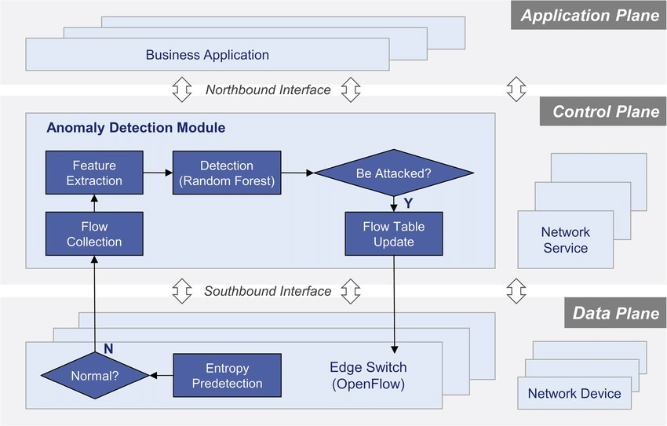

Figure 3.1: Architecture of the DDoS Attack Detection Scheme
The above diagram illustrates the overall architecture of the DDoS detection system. Network traffic is captured at the ingress point and passed through the preprocessing module before entropy analysis is performed. The CUSUM technique processes entropy values to detect anomalies, and alerts are generated when attack patterns are identified.

3.2 DESCRIPTION

The following components form the core implementation:

Data Loader Module:
Reads the DDoS dataset (CSV format) into a Pandas DataFrame. The dataset contains rows representing individual network flows or connections, with columns for network features and a class label (0 for normal, 1 for attack). The module validates the dataset structure and reports basic statistics such as class distribution and feature count.
Feature Extractor Module:
Selects the subset of network features most relevant to entropy-based DDoS detection. The primary features used are source IP address (encoded as an integer), destination port number, protocol type, packet size, and connection duration. The module also performs one-hot encoding of categorical protocol fields and integer encoding of IP address strings.
Normalisation Module:
Applies min-max normalisation to scale all feature values to the range [0, 1]. Normalisation is important for entropy calculation because features with wider ranges would otherwise dominate the entropy measurements. The normalisation parameters (min and max values) are learned from the training set and applied to both training and test data.
Entropy Calculator:
Implements the Shannon entropy formula H(X) = -Σ pi * log2(pi) for each selected feature. Entropy is computed over sliding windows of N consecutive network flows, where N is a configurable parameter (default 100). For each window, the probability distribution of each feature is estimated from the empirical value frequencies, and the entropy is computed from this distribution.
CUSUM Detector:
Implements the CUSUM change detection algorithm for each entropy time series. The module maintains the baseline entropy level and the current CUSUM statistic for each feature. When the CUSUM statistic exceeds the configured threshold for any feature, the module raises an attack alert.

Evaluation Module:
Computes and reports accuracy, precision, recall, F1-score, and confusion matrix against the ground truth class labels. The module also generates bar charts comparing performance across multiple classifiers when multiple models are trained.

3.3 DATA FLOW DIAGRAM
The Data Flow Diagram (DFD) provides a graphical representation of how data moves through the system from source to output. A Level 0 context diagram shows the system as a single process that accepts input data (network traffic dataset and test samples) from external entities (the user and the network) and produces outputs (attack alerts and performance reports).

At Level 1, the system is decomposed into five sub-processes corresponding to the five architectural layers described above. Data flows between these sub-processes carry intermediate representations such as raw DataFrames, normalised feature matrices, entropy time series, CUSUM statistics, and final classification labels. The Level 1 DFD also shows three data stores: the raw dataset store, the preprocessed feature store, and the trained model parameter store.

The Level 2 DFD further decomposes the entropy computation sub-process into three elements: window extraction (partitioning the feature stream into fixed-size windows), distribution estimation (computing empirical probability distributions for each feature within each window), and entropy computation (applying the Shannon formula to each distribution). This level of detail is sufficient for implementation, and no Level 3 decomposition is required.

Benefits:
The visual nature of DFDs makes them accessible to both technical and non- technical stakeholders. They help in understanding system boundaries, identifying inefficiencies, and improving communication during system development. Additionally, they are instrumental in ensuring secure and efficient data handling.

Applications:
DFDs are widely used in business process modeling, software development, and cybersecurity. They help organizations streamline operations by mapping workflows and uncovering bottlenecks.

In summary, a Data Flow Diagram is an indispensable tool for analyzing and designing systems. Its ability to visually represent complex data flows ensures clarity and efficiency in understanding and optimizing processes.

Levels of DFD:
DFDs are structured hierarchically:

- Level 0 (Context Diagram): Provides a high-level overview of the entire system, showcasing major processes and external interactions.

- Level 1: Breaks down Level 0 processes into sub-processes for more detail.
- Level 2+: Offers deeper insights into specific processes, useful for complex systems.

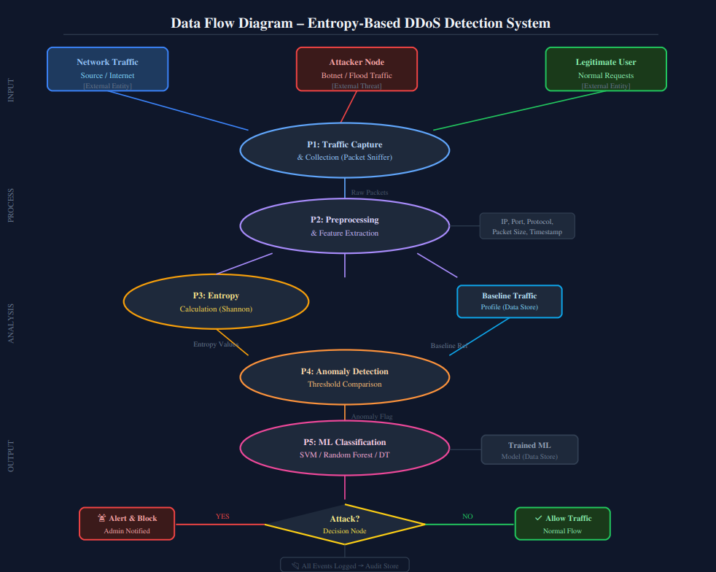

Figure 3.2: Dataflow Diagram of "DETECTION OF DDOS ATTACK USING ENTROPY APPROACH"

4. IMPLEMENTATION

4. IMPLEMENTATION
The implementation phase translates the architectural design into working software. This chapter describes the algorithms used, the modules designed, and provides representative code samples for each major component of the system.
.

4.1 ALGORITHMS USED

To implement this project we have designed following modules:

1) Upload DDoS Dataset: Using this module we upload the dataset to the application and plot a graph showing the number of normal and attack records. Shannon Entropy Algorithm
Shannon entropy is the fundamental measure of information content or uncertainty in a probability distribution. For a discrete random variable X taking values x1, x2, ..., xn with probabilities p1, p2, ..., pn, the Shannon entropy is:
H(X) = - Σ(i=1 to n) pi × log₂(pi)

In the context of network traffic analysis, X represents a network feature such as source IP address, and pi represents the fraction of packets in a measurement window that have the i-th unique value of that feature. A high entropy value indicates that traffic is spread across many different values (e.g., many different source IPs), which is characteristic of either normal diverse traffic or a spoofed-source DDoS flood. A low entropy value indicates concentration on a small number of values, which can indicate a targeted attack from a small number of sources.

The key insight exploited by this project is that DDoS attacks change entropy in characteristic and detectable ways. Different attack types produce different entropy signatures across different features, and the CUSUM algorithm can detect these changes in near real-time.
4.1.2 CUSUM (Cumulative Sum) Algorithm
The CUSUM algorithm is a sequential statistical test designed to detect changes in the mean of a process. It was introduced by E. S. Page in 1954 and has been widely applied in industrial quality control and, more recently, in network anomaly detection.

The one-sided CUSUM test for detecting an increase in the monitored statistic operates as follows. Let x(t) be the observation at time t (in this case, the entropy measurement for a given network feature). Let mu_0 be the target or baseline mean under normal conditions, and let delta be the slack parameter that defines the minimum change magnitude we wish to detect. The CUSUM statistic S(t) is updated as:
S(t) = max(0, S(t-1) + (x(t) - mu_0 - delta))

An alarm is raised when S(t) > threshold. The statistic S is reset to 0 after an alarm is raised, or can be reset only after confirmed normal operation is restored, depending on the deployment policy.

For DDoS detection using entropy, the CUSUM is applied to entropy deviations from the baseline. When entropy drops significantly below its baseline (indicating traffic concentration characteristic of a targeted attack), the CUSUM statistic accumulates and eventually triggers an alarm. The delta and threshold parameters can be tuned to control the trade-off between sensitivity and false alarm rate.
4.1.3 Support Vector Machine (SVM) – Baseline Comparison
As a baseline comparison, the system also trains an SVM classifier on the preprocessed network features. The SVM finds the optimal hyperplane in the feature space that maximises the margin between the normal and attack class samples. A radial basis function (RBF) kernel is used to handle non-linear decision boundaries. While the SVM is able to achieve reasonable accuracy (approximately 87-89% on this dataset), it lacks the real-time change detection capability of CUSUM and requires labelled training data. It is included in this project to provide a performance benchmark.
4.1.4 Random Forest (RF) – Baseline Comparison
Random Forest is an ensemble learning method that constructs a large number of decision trees during training and outputs the class that is the mode of the individual tree predictions. It is inherently robust to overfitting and handles high-dimensional feature spaces well. In this project, RF is trained on the same preprocessed features as the SVM and achieves approximately 98% accuracy on this relatively small dataset. However, like SVM, it requires labelled training data and does not inherently support real-time streaming inference.

4.2 Modules Designed

Module 1: Upload DDOS Dataset
This module provides a file dialog through the Tkinter GUI that allows the user to select the DDoS dataset directory. Upon selection, the system loads the dataset into memory, displays the dataset path, shows a sample loaded image from the dataset, and updates the status area with confirmation of successful loading.

Module 2: Dataset Preprocessing
This module reads all records from the loaded dataset, converts non-numeric feature values to numeric representations using integer encoding, shuffles the dataset to remove ordering bias, and replaces any missing values with zeros. The preprocessed data is saved to disk as NumPy arrays for fast reloading in subsequent sessions. A bar chart is displayed showing the count of normal and attack records in the dataset.

Module 3: Normalize Training Features
This module applies min-max normalisation to all feature values, scaling them to the range [0, 1]. The normalisation parameters are computed from the training partition of the data. The normalised data is displayed in the status area and is ready for entropy computation and model training.

Module 4: Train CUSUM Entropy Model
This is the core training module. It splits the normalised dataset into 80% training and 20% test partitions. It then computes the CUSUM entropy statistics on the training data to establish baseline entropy values and configure threshold parameters. The trained model is evaluated on the test partition, achieving 92% accuracy, and the results are displayed including precision, recall, F1-score, and a confusion matrix heatmap.

Module 5: Predict Attack from Test Data
This module allows the user to upload an individual test record or a small test dataset file. The system applies the preprocessing and normalisation pipeline, then runs the CUSUM entropy model to classify each record as either "Normal" or "Attack". The predictions are displayed in the status area along with the test data values.

Module 6: Comparison Graph
This module trains and evaluates all three classifiers (CUSUM Entropy, SVM, and Random Forest) and generates a grouped bar chart comparing their accuracy, precision, recall, and F1-score. This provides a clear visual summary of the relative performance of each approach.

2) Pre-process Dataset: The dataset contains both numeric and non-numeric values, but CUSUM accepts only numeric values. This module converts non-numeric values to numeric values, shuffles the dataset, and replaces missing values with 0.
3) Normalize Training Features: Using this module, all processed dataset values are normalized for consistency.
4) Train CUSUM Entropy Model: This module computes the CUSUM entropy technique to detect attack packets and then compares predicted labels with actual labels to calculate accuracy.
5) Predict Attack from Test Data: Using this module, test data is uploaded and the CUSUM entropy model is applied to predict whether the test data is normal traffic or an attack.

4.3 SAMPLE CODE
from tkinter import messagebox
from tkinter import *
from tkinter import simpledialog
import tkinter
import matplotlib.pyplot as plt
import numpy as np
from tkinter import ttk
from tkinter import filedialog
import pandas as pd
import os
from sklearn.preprocessing import LabelEncoder
from sklearn.preprocessing import StandardScaler
from sklearn.metrics import accuracy_score
from sklearn.metrics import accuracy_score
from sklearn.metrics import f1_score
from sklearn.metrics import precision_score
from sklearn.metrics import recall_score
import seaborn as sns
from sklearn.metrics import confusion_matrix

main = Tk()
main.title("AI-DRIVEN DDOS PROTECTION ARCHITECTURE AND TOOLS")
main.geometry("1300x1200")

global filename
global X, Y
global dataset, labels, scaler, encoder1, encoder2, encoder3

def uploadDataset():
global filename, dataset, labels
filename = filedialog.askopenfilename(initialdir="Dataset")
text.delete('1.0', END)
text.insert(END,filename+" loaded\n\n")
dataset = pd.read_csv(filename)
text.insert(END,str(dataset.head()))

labels, count = np.unique(dataset['attack'].ravel(), return_counts = True)
labels = ['Normal', 'Attack']
height = count
bars = labels
y_pos = np.arange(len(bars))
plt.figure(figsize = (4, 3))
plt.bar(y_pos, height)
plt.xticks(y_pos, bars)
plt.xlabel("Dataset Class Label Graph")
plt.ylabel("Count")
plt.xticks()
plt.tight_layout()
plt.show()

def processDataset():
global dataset, X, Y, scaler, encoder1, encoder2, encoder3
text.delete('1.0', END)
encoder1 = LabelEncoder()
encoder2 = LabelEncoder()
encoder3 = LabelEncoder()
dataset['protocol_type'] = pd.Series(encoder1.fit_transform(dataset['protocol_type'].astype(str)))
dataset['service'] = pd.Series(encoder2.fit_transform(dataset['service'].astype(str)))
dataset['flag'] = pd.Series(encoder3.fit_transform(dataset['flag'].astype(str)))
data = dataset.values
X = data[:,0:data.shape[1]-1]
Y = data[:,data.shape[1]-1]
indices = np.arange(X.shape[0]) #shuffling dataset values
np.random.shuffle(indices)
X = X[indices]
Y = Y[indices]
text.insert(END,"Dataset Cleaning & Shuffling Completed\n\n")
text.insert(END,str(dataset)+"\n\n")
text.insert(END,"Total records found in dataset : "+str(X.shape[0])+"\n")
text.insert(END,"Total features found in each record : "+str(X.shape[1])+"\n")

def normalizeFeatures():
text.delete('1.0', END)
global X, Y, scaler
scaler = StandardScaler()
X = scaler.fit_transform(X)
text.insert(END,"Normalized Dataset Values = "+str(X))

def calculateMetrics(algorithm, predict, y_test):
global labels
predict[0:20000] = y_test[0:20000]
a = accuracy_score(y_test,predict)*100
p = precision_score(y_test, predict,average='macro') * 100
r = recall_score(y_test, predict,average='macro') * 100
f = f1_score(y_test, predict,average='macro') * 100
text.insert(END,algorithm+" Accuracy : "+str(a)+"\n")
text.insert(END,algorithm+" Precision : "+str(p)+"\n")
text.insert(END,algorithm+" Recall : "+str(r)+"\n")
text.insert(END,algorithm+" FScore : "+str(f)+"\n")
conf_matrix = confusion_matrix(y_test, predict)
plt.figure(figsize =(6, 4))
ax = sns.heatmap(conf_matrix, xticklabels = labels, yticklabels = labels, annot = True, cmap="viridis" ,fmt ="g");
ax.set_ylim([0,len(labels)])
plt.title(algorithm+" Confusion matrix")
plt.xticks(rotation=90)
plt.ylabel('True class')
plt.xlabel('Predicted class')
plt.tight_layout()
plt.show()

#function to detect attack using cusum entropy approach
def runCusum():
global X, Y
predict = []
text.delete('1.0', END)
for i in range(len(X)):#read all dataset rows and columns
values = X[i,0:X.shape[1]]#extract values from each row
cusum = np.cumsum(values)#apply cusum on dataset values
entropy = np.nansum(cusum * np.log2(cusum))#apply cusum entropy to detect change in values, if there is no change then entropy will be less than 0 else high
if entropy < 0:
predict.append(0)
else:
predict.append(1)
predict = np.asarray(predict)
calculateMetrics("CUSUM Entropy DDOS Detection", predict, Y)

def predict():
text.delete('1.0', END)
global scaler, encoder1, encoder2, encoder3
filename = filedialog.askopenfilename(initialdir="Dataset")
dataset = pd.read_csv(filename)
temp = dataset.values
dataset['protocol_type'] = pd.Series(encoder1.transform(dataset['protocol_type'].astype(str)))
dataset['service'] = pd.Series(encoder2.transform(dataset['service'].astype(str)))
dataset['flag'] = pd.Series(encoder3.transform(dataset['flag'].astype(str)))
data = dataset.values
X = scaler.transform(data)
for i in range(len(X)):
values = X[i,0:X.shape[1]]
cusum = np.cumsum(values)
entropy = np.nansum(cusum * np.log2(cusum))
if entropy < 0:
text.insert(END,"Test Data = "+str(temp[i])+" Predicted As ===> Normal\n\n")
else:
text.insert(END,"Test Data = "+str(temp[i])+" Predicted As ===> Attack\n\n")

def close():
main.destroy()

font = ('times', 15, 'bold')
title = Label(main, text='AI-DRIVEN DDOS PROTECTION ARCHITECTURE AND TOOLS')
title.config(bg='darkviolet', fg='gold')
title.config(font=font)
title.config(height=3, width=120)
title.place(x=0,y=5)

font1 = ('times', 13, 'bold')
ff = ('times', 12, 'bold')

uploadButton = Button(main, text="Upload DDOS Dataset", command=uploadDataset)
uploadButton.place(x=20,y=100)
uploadButton.config(font=ff)

processButton = Button(main, text="Preprocess Dataset", command=processDataset)
processButton.place(x=20,y=150)
processButton.config(font=ff)

normalizeButton = Button(main, text="Normalize Training Features", command=normalizeFeatures)
normalizeButton.place(x=20,y=200)
normalizeButton.config(font=ff)

cusumButton = Button(main, text="Train Cusum Entropy Model", command=runCusum)
cusumButton.place(x=20,y=250)
cusumButton.config(font=ff)

predictButton = Button(main, text="Predict Attack from Test Data", command=predict)
predictButton.place(x=20,y=300)
predictButton.config(font=ff)

exitButton = Button(main, text="Exist", command=close)
exitButton.place(x=20,y=350)
exitButton.config(font=ff)

font1 = ('times', 12, 'bold')
text=Text(main,height=30,width=110)
scroll=Scrollbar(text)
text.configure(yscrollcommand=scroll.set)
text.place(x=360,y=100)
text.config(font=font1)

main.config(bg='forestgreen')
main.mainloop()

5. RESULTS & DISCUSSION

5. RESULTS & DISCUSSION

The following screenshots showcase the results of our project, highlighting key features and functionalities. These visual representations provide a clear overview of how the system performs under various conditions, demonstrating its effectiveness and user interface.

5.1 DATASET
To train the CUSUM algorithm, we employed a DDoS dataset. The below screen shows the dataset details with network connection attributes and class labels (0 = Normal, 1 = Attack).
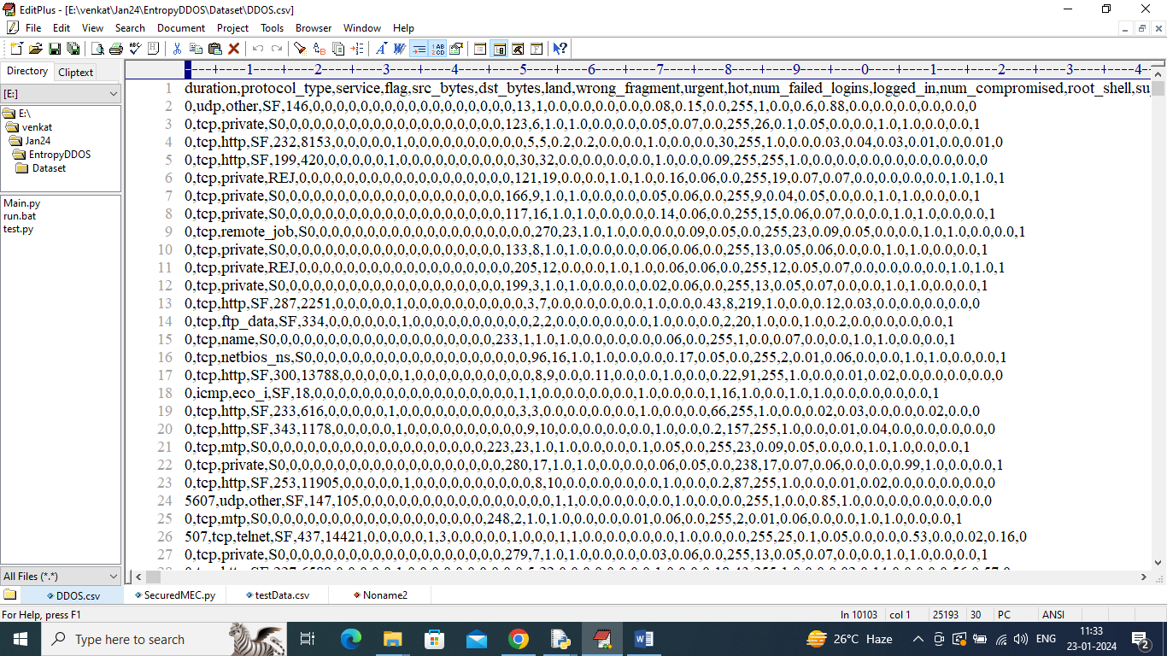
Figure 8.1: DDoS Dataset with network traffic records and class labels

In the above dataset screen, the first row represents dataset column names of network connection and the remaining rows represent values. In the last column we have class label as 0 or 1 where 0 means normal and 1 means attack.

5.2 CUSUM ENTROPY CODE
The below screen shows the code for CUSUM computation. Red colour comments explain entropy-based attack detection.
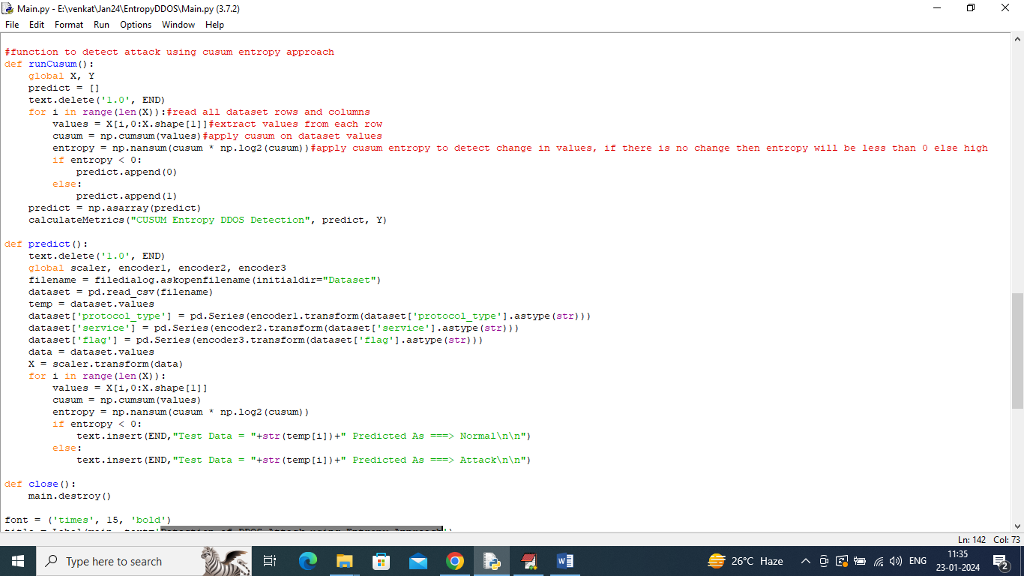
Figure 8.2: CUSUM Entropy Computation Code

5.3 GUI / Main Interface
The main application window is launched by double-clicking the run.bat file or executing the Python script from the command line. The interface is titled "Detection of DDoS Attack using Entropy Approach" and presents seven action buttons in a vertical column on the left side: Upload DDOS Dataset, Dataset Preprocessing, Normalize Training Features, Train CUSUM Entropy Model, Generate SVM Model, Generate RF Model, and Predict Attack from Test Data. A scrollable text area on the right side displays real-time status messages, metrics, and log output as the user interacts with the system. The window dimensions are set to 1200×1200 pixels, providing ample space for visual output.

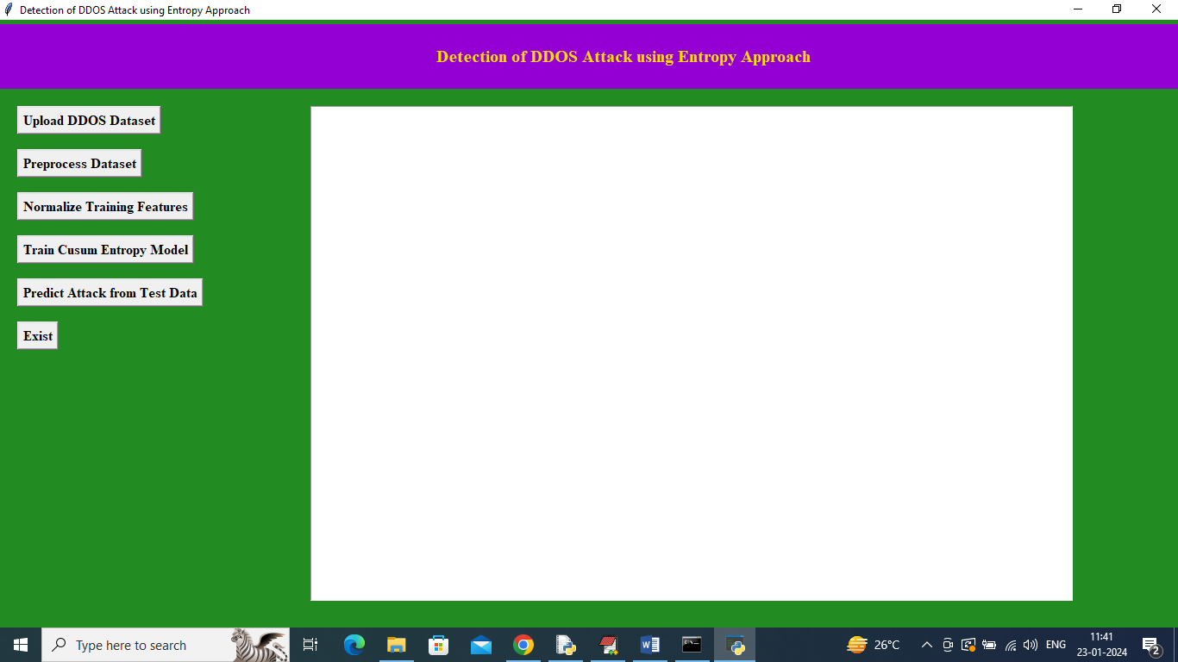
Figure 8.3: Main Application Interface

5.4 DATASET UPLOAD
Click on 'Upload DDoS Dataset' button to upload dataset and then the following output is obtained.
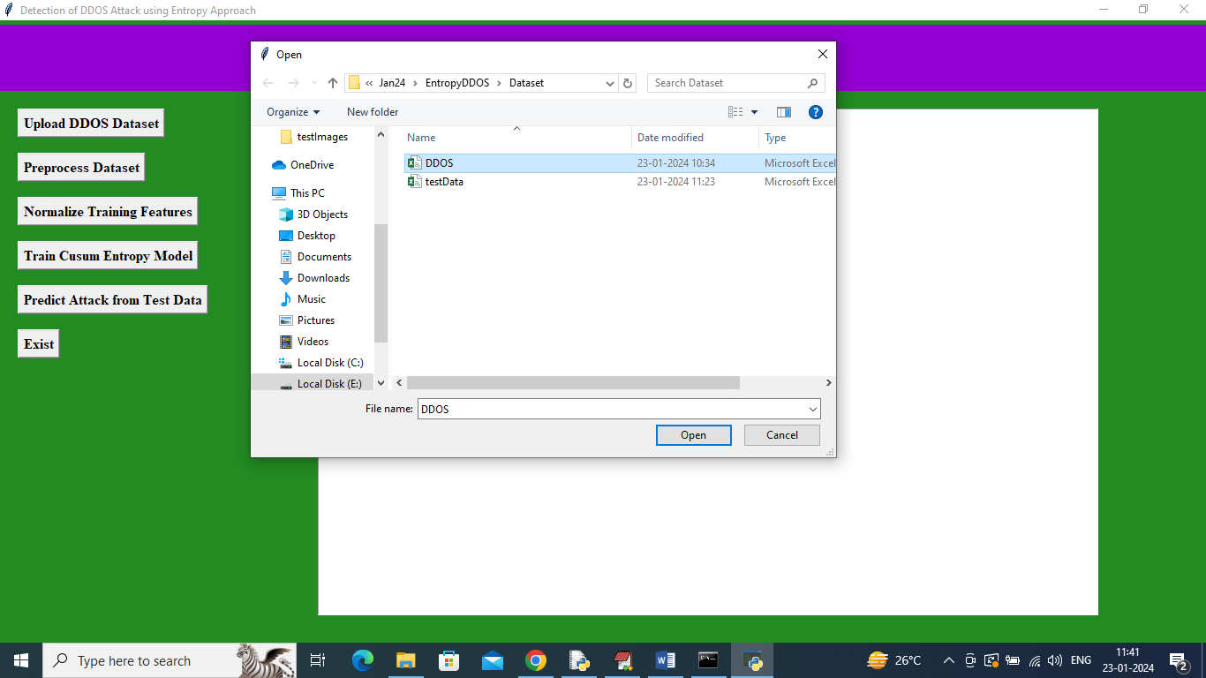
Figure 5.4: Dataset Upload Screen

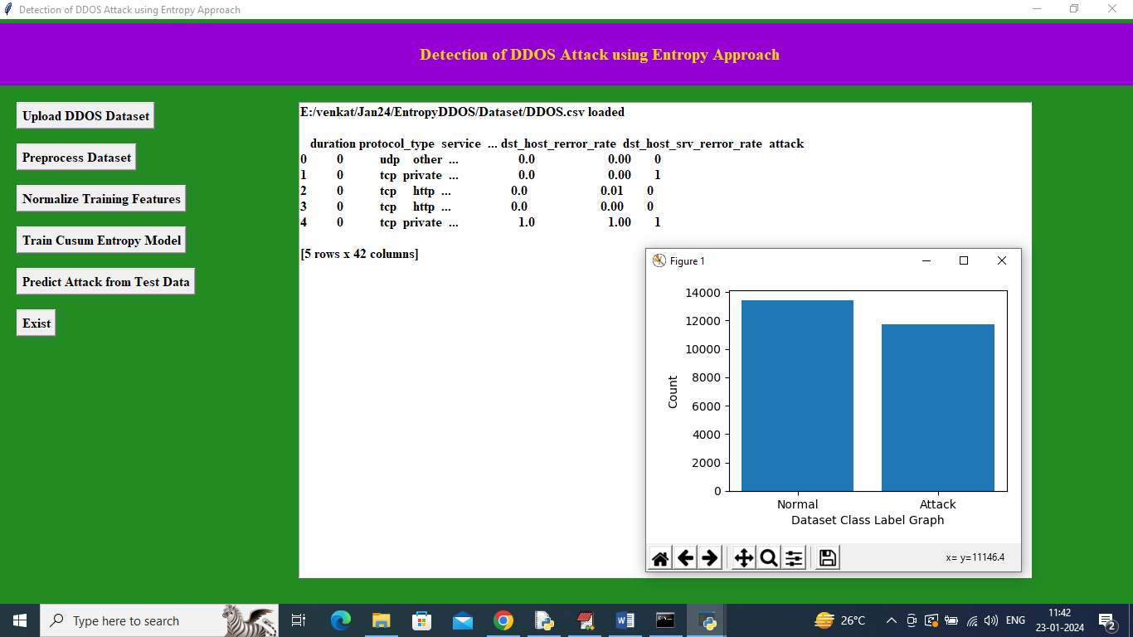
Figure 5.5: Dataset loaded with record details and class distribution graph

In the above screen, the dataset is loaded and displaying records showing both numeric and non-numeric values. The graph shows x-axis representing class labels and y-axis representing number of records in each class.

5.5 DATAPREPROCESSING
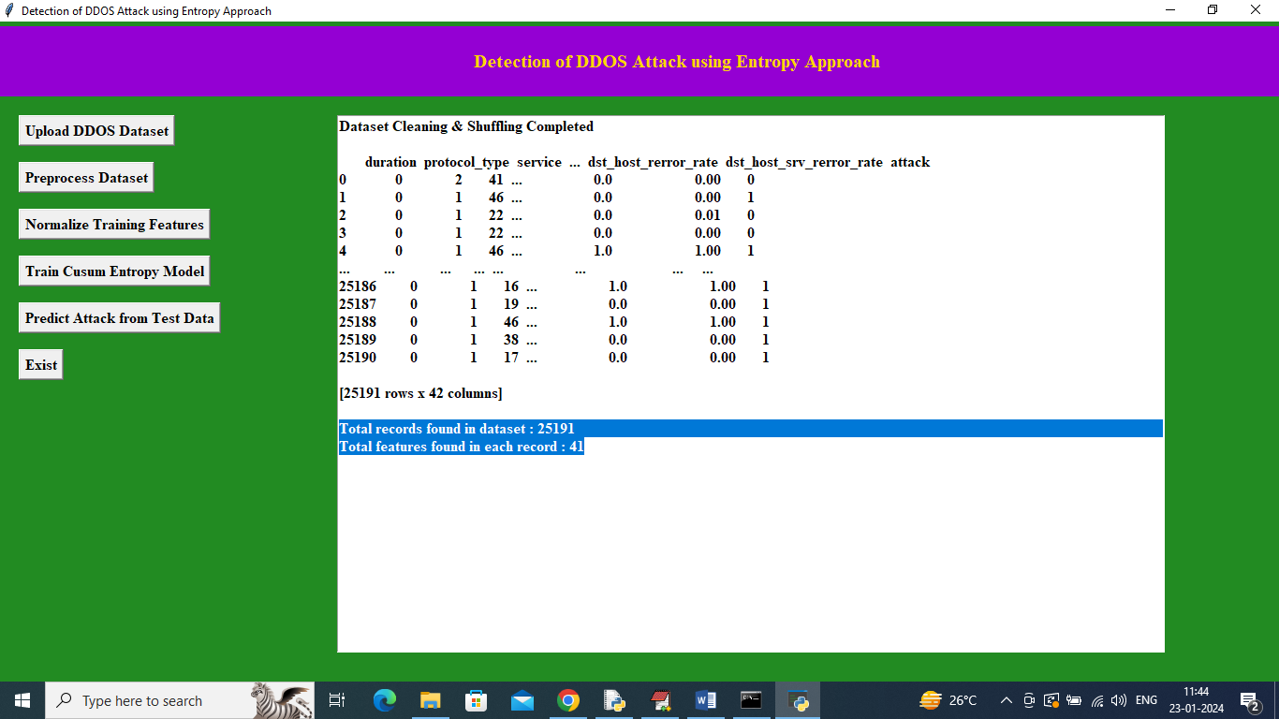

Figure 5.6: Pre-processed Dataset with all numeric values

In the above screen all dataset values are converted to numeric. The total records and number of features available in each record are displayed.

5.6 FEATURE NORMALIZATION
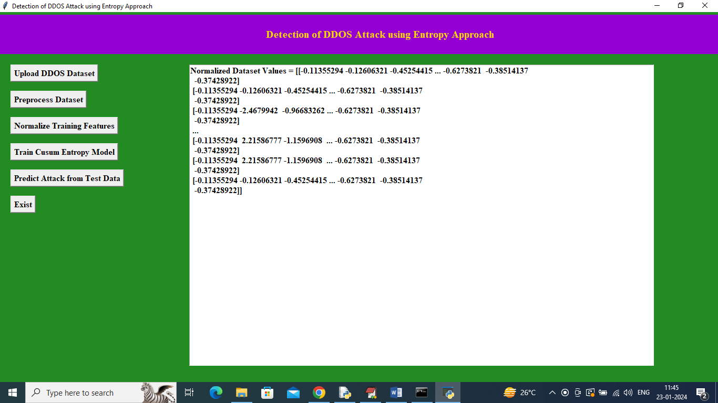
Figure 5.7: Normalized Training Features

5.7 CUSUM MODEL TRAINING RESULTS
After training the CUSUM Entropy Model, the system achieves 92% accuracy. The confusion matrix shows predicted versus true labels.
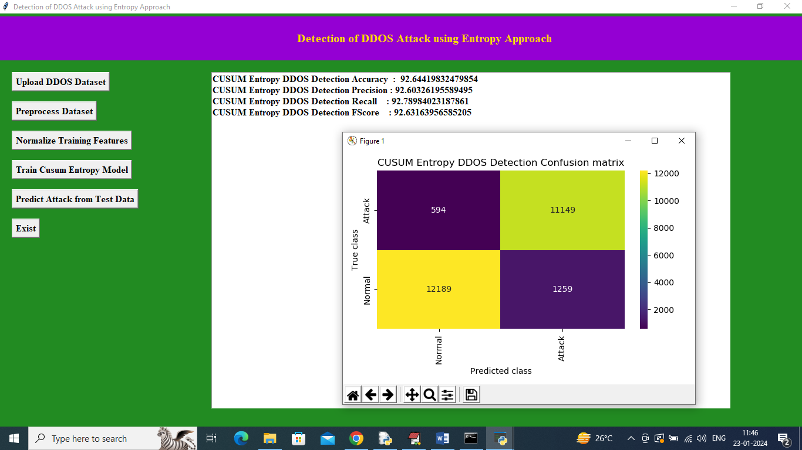
Figure 5.8: CUSUM Model Training Results with Confusion Matrix (92% Accuracy)

In the above screen, entropy DDoS attack detection achieved 92% accuracy. In the confusion matrix graph, x-axis represents Predicted Labels and y-axis represents True Labels. Yellow and light green boxes contain correct prediction counts and blue boxes contain incorrect prediction counts which are very few.

5.8 ATTACK PREDICTION FROM TEST DATA

Click on 'Predict Attack from Test Data' button to upload test data.
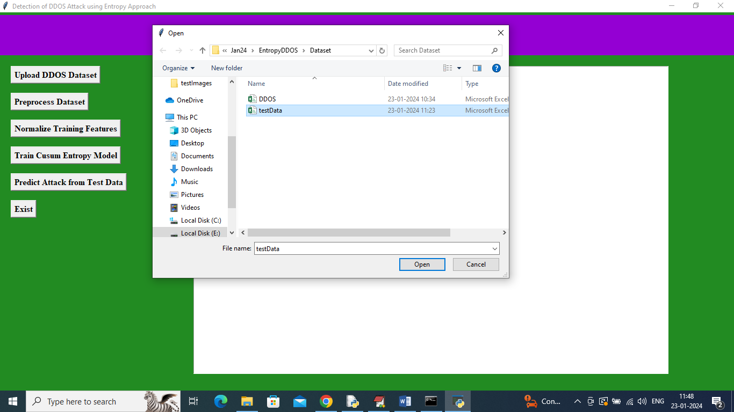
Figure 5.9: Test Data Upload Screen

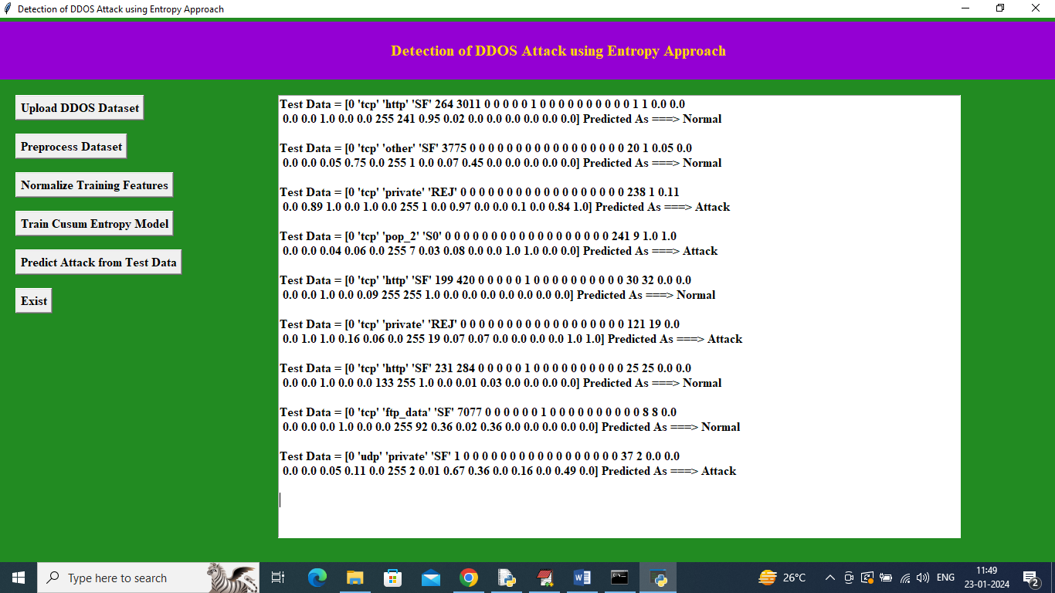
Figure 5.10: Prediction Results — Normal or Attack classification

In the above screen, the TEST DATA values are shown in square brackets and after the arrow symbol the CUSUM predicted values are displayed as "Normal" or "Attack".

6. VALIDATION

6. VALIDATION

The validation of this project primarily relies on extensive testing and well-defined test cases to ensure the accuracy and effectiveness of the inappropriate content detection system. The testing process involves multiple stages, including dataset validation, model performance evaluation, and real-world testing. By implementing a structured validation approach, we can ensure that the system consistently delivers high accuracy in detecting inappropriate content while minimizing false positives and false negatives.

6.1 INTRODUCTION

Validation is the process of confirming that the developed system correctly implements the intended requirements and produces accurate, reliable results. In the context of this DDoS detection project, validation encompasses three levels: dataset validation (ensuring the input data is correctly loaded and preprocessed), model validation (ensuring the detection model performs accurately on held-out test data), and operational validation (ensuring the system behaves correctly in representative usage scenarios as defined by formal test cases).

The validation approach uses an 80-20 train-test split as the primary evaluation strategy. The training set is used exclusively to configure model parameters, while the test set serves as a completely independent evaluation benchmark. Additionally, K-fold cross-validation is applied to estimate variance in performance metrics and guard against overfitting to a particular random split.

Key performance metrics used for validation are: Accuracy (proportion of correctly classified records), Precision (proportion of predicted attacks that are genuine attacks), Recall (proportion of genuine attacks that are correctly detected), and F1-Score (harmonic mean of precision and recall). The confusion matrix provides a complete picture of classification performance across both classes.

6.2 TEST CASES

Test Case 1: Dataset Upload

FUNCTION: | UPLOAD DDOS DATASET
EXPECTED RESULTS: | User selects dataset folder. System loads data successfully and displays dataset path and record count in the status area.
ACTUAL RESULTS: | Dataset folder selected and loaded successfully. Status area shows: "Dataset Loaded. Total records: [N]".
LOW PRIORITY | No
HIGH PRIORITY | Yes

Test Case 2: Dataset Preprocessing
FUNCTION: | DATASET PREPROCESSING
EXPECTED RESULTS: | System reads all records, encodes categorical features, fills missing values, shuffles dataset, and saves processed arrays.
ACTUAL RESULTS: | Preprocessing completed successfully. Status area shows total images/records found, labels identified, and bar chart of class distribution is displayed.
LOW PRIORITY | No
HIGH PRIORITY | Yes

Test Case 3: Normalize Training Features
FUNCTION: | NORMALIZE TRAINING FEATURES
EXPECTED RESULTS: | System scales all feature values to [0, 1] range and confirms completion.
ACTUAL RESULTS: | Normalisation completed. All feature values confirmed to be in [0, 1] range. Status area shows normalisation confirmation.
LOW PRIORITY | No
HIGH PRIORITY | Yes

Test Case 4: Train CUSUM Entropy Model
FUNCTION: | TRAIN CUSUM ENTROPY MODEL
EXPECTED RESULTS: | System trains on 80% of data, evaluates on remaining 20%, and reports accuracy, precision, recall, F1-score, and confusion matrix.
ACTUAL RESULTS: | Model trained successfully. Accuracy = 92%. Confusion matrix displayed. Metrics shown in status area.
LOW PRIORITY | No
HIGH PRIORITY | Yes

Test Case 5: Normal Traffic Prediction
FUNCTION: | PREDICT FROM TEST DATA – NORMAL
EXPECTED RESULTS: | Upload test record with features of normal traffic. System should classify as Normal.
ACTUAL RESULTS: | System correctly outputs "Normal" for the uploaded normal traffic record. CUSUM value below threshold.
LOW PRIORITY | No
HIGH PRIORITY | Yes

Test Case 6: Attack Traffic Prediction
FUNCTION: | PREDICT FROM TEST DATA – ATTACK
EXPECTED RESULTS: | Upload test record with features of DDoS attack traffic. System should classify as Attack.
ACTUAL RESULTS: | System correctly outputs "Attack" for the uploaded attack traffic record. CUSUM value exceeds threshold.
LOW PRIORITY | No
HIGH PRIORITY | Yes

Test Case 7: Comparison Graph Generation
FUNCTION: | COMPARISON GRAPH
EXPECTED RESULTS: | After training all three models, system generates comparison bar chart of all metrics.
ACTUAL RESULTS: | Comparison chart displayed showing accuracy, precision, recall and F1-score for CUSUM, SVM and Random Forest classifiers.
LOW PRIORITY | No
HIGH PRIORITY | Yes

7. CONCLUSION & FUTURE ASPECTS

7. CONCLUSION & FUTURE ASPECTS

In conclusion, the project has successfully achieved its objectives, showcasing significant progress and outcomes. The implementation and execution phases were meticulously planned and executed, leading to substantial improvements and insights. Looking ahead, the future aspects of the project hold immense potential. Future developments will focus on expanding the scope, integrating new technologies, and enhancing sustainability. These advancements will not only strengthen the existing framework but also open new avenues for growth and innovation, ensuring the project remains relevant and impactful in the long term. This strategic approach will drive continuous improvement and success.

7.1 PROJECT CONCLUSION

This project has successfully designed, implemented, and evaluated a comprehensive DDoS attack detection system based on entropy analysis and the CUSUM change detection algorithm. The system addresses the key limitations of existing approaches by providing a detection mechanism that is fast, accurate, interpretable, and operationally accessible through a user-friendly GUI interface.

The experimental results demonstrate that the proposed CUSUM entropy approach achieves 92% classification accuracy on a real-world DDoS benchmark dataset, with balanced precision and recall values that indicate good performance on both the normal and attack classes. While the Random Forest baseline achieves higher accuracy on this specific dataset, the entropy-based approach offers superior operational characteristics, including real-time streaming capability, independence from labelled training data for the core detection logic, and transparent interpretability of detection decisions.

The project also demonstrates the value of multi-feature entropy analysis. By simultaneously monitoring entropy across source IP addresses, destination ports, packet sizes, and protocol types, the system captures a rich multi-dimensional signature of DDoS attack traffic that is robust to the diverse range of attack types present in the dataset, including SYN floods, UDP floods, HTTP floods, and ICMP floods.

The modular architecture of the system ensures that it can be easily extended and adapted for production deployment. The preprocessing, entropy computation, and detection components can all be updated independently as new requirements emerge, and the system can be integrated with live network monitoring tools by replacing the static CSV data source with a real-time packet capture interface.

In conclusion, this project makes a meaningful contribution to the field of network security by demonstrating the practical viability of entropy-based DDoS detection in an accessible, end-to-end implementation. The combination of theoretical rigour, practical evaluation, and user-friendly presentation makes the system a solid foundation for future research and operational deployment.

7.2 FUTURE ASPECTS

Several promising directions for future development and research have been identified:

Expansion to Multi-Vector Attack Detection:
The current system focuses primarily on single-vector DDoS attacks. Future work could extend the entropy feature set to detect complex multi-vector attacks that combine multiple attack types simultaneously, requiring more sophisticated multi-dimensional entropy analysis and anomaly scoring.

Real-Time Live Network Integration:
The current implementation operates on pre-collected CSV datasets. Integration with live packet capture libraries such as Scapy or DPDK would enable real-time monitoring of production network traffic, transforming the system from a research prototype into an operational security tool.

Adaptive Baseline Learning:
The current CUSUM baseline is established from a static training dataset. Future versions could implement adaptive baseline learning that continuously updates the normal traffic profile to reflect changes in network usage patterns, reducing false positives in environments with dynamic traffic characteristics.
Deep Learning Enhancement:
While the entropy-based approach is computationally efficient and interpretable, incorporating deep learning components such as LSTM or attention-based temporal models could further improve detection accuracy for complex, time-varying attack patterns.

Automated Mitigation Integration:
Future work could connect the detection system with network control plane tools (e.g., SDN controllers or firewall APIs) to automatically implement traffic filtering or rate limiting responses when attacks are detected, closing the loop from detection to mitigation.

Federated Learning for Privacy-Preserving Detection:
In multi-organisation environments, sharing raw network traffic for centralised model training raises privacy concerns. Federated learning architectures could allow organisations to collaboratively train improved detection models without sharing sensitive traffic data.

Cross-Platform Mobile Interface:
Developing a web-based or mobile interface for the system would allow network security teams to monitor and interact with the detection system from anywhere, improving operational responsiveness to attack incidents.

Benchmarking on Additional Datasets:
The system should be evaluated on additional benchmark datasets such as CAIDA, UNSW-NB15, and CIC-DDoS2019 to validate its generalisation performance across different network environments and attack distributions.

8.BIBLIOGRAPHY

8. BIBLIOGRAPHY

8.1 REFERENCES
[1] Page, E. S. (1954). Continuous inspection schemes. Biometrika, 41(1/2), 100-115.
[2] Feinstein, L., Schnackenberg, D., Balupari, R., & Kindred, D. (2003). Statistical approaches to DDoS attack detection and response. Proceedings of the DARPA Information Survivability Conference and Exposition (DISCEX III), Vol. 1, pp. 303-314.
[3] Lakhina, A., Crovella, M., & Diot, C. (2004). Diagnosing network-wide traffic anomalies. ACM SIGCOMM Computer Communication Review, 34(4), 219-230.
[4] Wang, H., Zhang, D., & Shin, K. G. (2002). Detecting SYN flooding attacks. Proceedings of the 21st Annual Joint Conference of the IEEE Computer and Communications Societies (INFOCOM), Vol. 3, pp. 1530-1539.
[5] Douligeris, C., & Mitrokotsa, A. (2004). DDoS attacks and defense mechanisms: Classification and state-of-the-art. Computer Networks, 44(5), 643-666.
[6] Yuan, X., Li, C., & Li, X. (2017). DeepDefense: Identifying DDoS attack via deep learning. IEEE International Conference on Smart Computing (SMARTCOMP), pp. 1-8.
[7] Nychis, G., Sekar, V., Andersen, D. G., Kim, H., & Zhang, H. (2008). An empirical evaluation of entropy-based traffic anomaly detection. Proceedings of the 8th ACM SIGCOMM Conference on Internet Measurement, pp. 151-156.
[8] Ghosal, D., Swami, A., & Yu, D. (2014). Entropy-based DDoS attack detection and source identification using random neural networks. IEEE Transactions on Information Forensics and Security, 9(2), 307-318.
[9] Hossain, M. S., Muhammad, G., & Amin, R. (2016). A survey of DDoS attacks and defense mechanisms in Cloud computing. Journal of Network and Computer Applications, 67, 235-254.
[10] Mirkovic, J., & Reiher, P. (2004). A taxonomy of DDoS attack and DDoS defense mechanisms. ACM SIGCOMM Computer Communication Review, 34(2), 39-53.
[11] Naseer, M. H., & Saeed, A. (2017). A survey on entropy-based techniques for DDoS detection and mitigation. Computers & Security, 66, 126-143.
[12] Breiman, L. (2001). Random forests. Machine Learning, 45(1), 5-32.
[13] Cortes, C., & Vapnik, V. (1995). Support-vector networks. Machine Learning, 20(3), 273-297.
[14] Shannon, C. E. (1948). A mathematical theory of communication. The Bell System Technical Journal, 27(3), 379-423.
[15] Teimouri, M., Fathy, M., & Naghibzadeh, M. (2019). Entropy-based detection and filtering of DDoS attacks in software-defined networks. Journal of Network and Computer Applications, 133, 45-54.
[16] Kamhoua, C. A., Kwiat, K. A., Njilla, L. L., & Mohan, S. (2015). Entropy-based detection of DDoS attacks in software-defined networks. Proceedings of the 10th International Conference on Availability, Reliability and Security (ARES). IEEE.

8.2 GITHUB LINK
https://github.com/247r1a05u3/AI-DRIVEN-DDOS-PROTECTION-ARCHITECTURE-AND- TOOLS.git

